Decision Tree Classification

|  |  |  |  |  |
| --- | --- | --- | --- | --- |
| Complexity penalty | Splits | n(Train) | n(Test) | Test Accuracy |
| 0.01 | 22 | 539 | 134 | 0.66 |
| **Data Split** |  |  |  |  |



Confusion Matrix

|  |  |  |  |  |  |  |
| --- | --- | --- | --- | --- | --- | --- |
|  | |  |  | Predicted |  | |
| 2 | 3 |  | 4 | 5 |
| Observed | 2 | 20 | 0 |  | 0 | 0 |
|  | 3 | 0 | 53 |  | 0 | 7 |
|  | 4 | 17 | 0 |  | 0 | 0 |
|  | 5 | 0 | 22 |  | 0 | 15 |

Class Proportions

Data Set Training Set Test Set

|  |  |  |  |
| --- | --- | --- | --- |
| 2 | 0.18 | 0.19 | 0.15 |
| 3 | 0.47 | 0.47 | 0.45 |
| 4 | 0.09 | 0.08 | 0.13 |
| 5 | 0.27 | 0.26 | 0.28 |

Obs. in Split Split Point Improvement

|  |  |  |  |
| --- | --- | --- | --- |
| DHC-IOTN | 539 | 6.00 | 35.18 |
| DHC-IOTN | 295 | 11.00 | 89.74 |
| AC-IOTN | 152 | 16.00 | 3.35 |
| AREA | 244 | 19.00 | 10.42 |

*Note.* For each level of the tree, only the split with the highest improvement in deviance is shown.

**ROC Curves Plot**

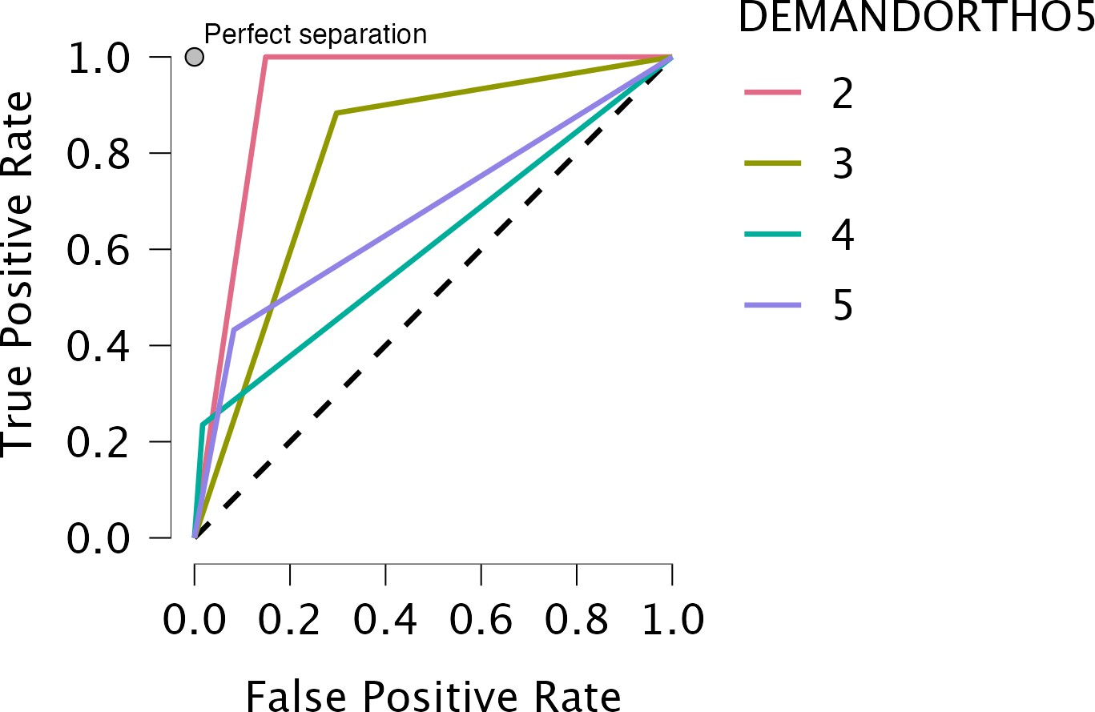

**Andrews Curves Plot**

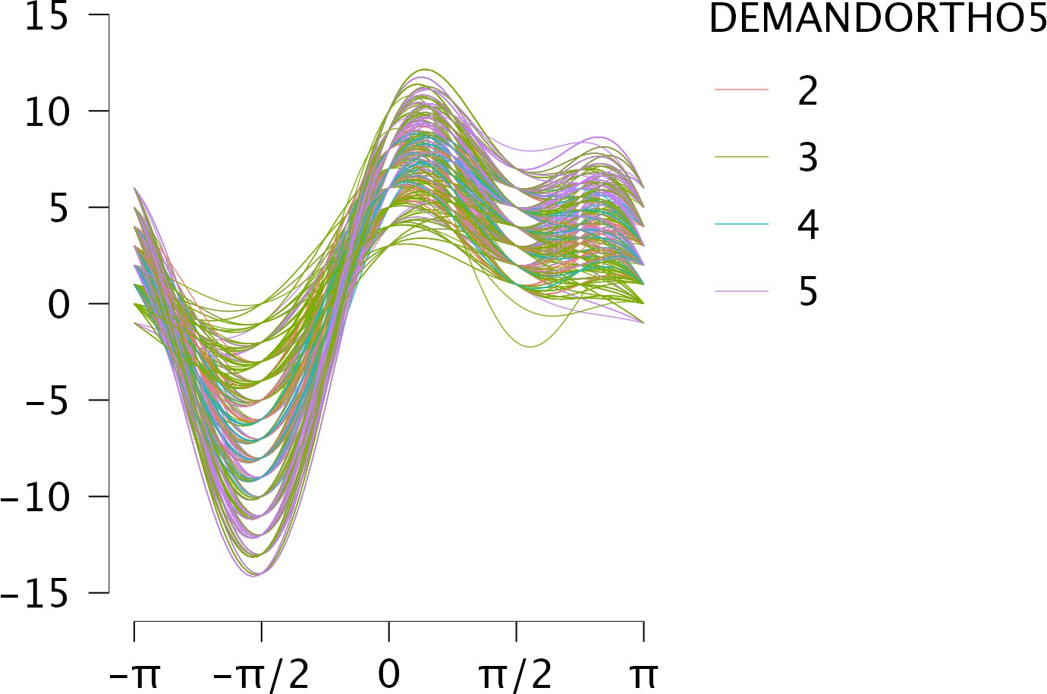

Decision Tree Classification

Complexity penalty Splits

n(Train)

n(Test)

Test Accuracy

# 0.01

20 539

134

0.66

*Note.* The trained model is not saved until 'Save trained model' is checked.

**Data Split**



Confusion Matrix

|  |  |  |  |  |  |  |
| --- | --- | --- | --- | --- | --- | --- |
|  | |  |  | Predicted |  | |
| 2 | 3 |  | 4 | 5 |
| Observed | 2 | 20 | 0 |  | 0 | 0 |
|  | 3 | 0 | 58 |  | 0 | 8 |
|  | 4 | 11 | 0 |  | 0 | 0 |
|  | 5 | 0 | 26 |  | 0 | 11 |

Class Proportions

Data Set Training Set Test Set

|  |  |  |  |
| --- | --- | --- | --- |
| 2 | 0.18 | 0.19 | 0.15 |
| 3 | 0.47 | 0.46 | 0.49 |
| 4 | 0.09 | 0.09 | 0.08 |
| 5 | 0.27 | 0.26 | 0.28 |

Obs. in Split Split Point Improvement

|  |  |  |  |
| --- | --- | --- | --- |
| DHC-IOTN | 539 | 8.00 | 38.71 |
| need3 |  |  |  |
| DHC-IOTN  need3 | 294 | 13.00 | 89.83 |
| AREA | 245 | 18.00 | 11.68 |

*Note.* For each level of the tree, only the split with the highest improvement in deviance is shown.

**ROC Curves Plot**

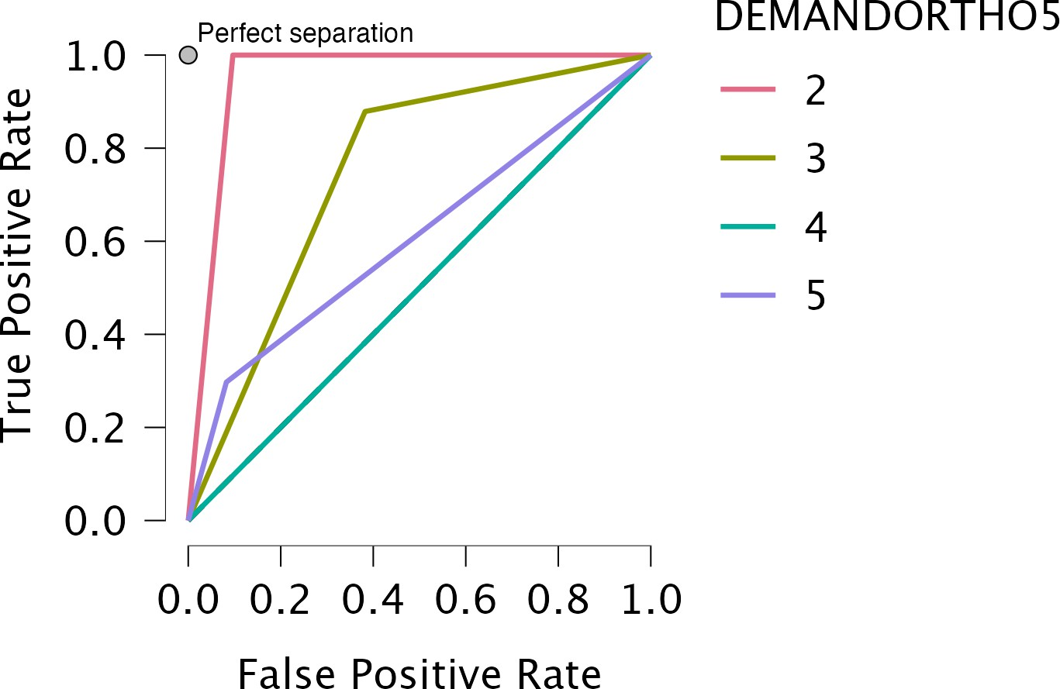

**Andrews Curves Plot**

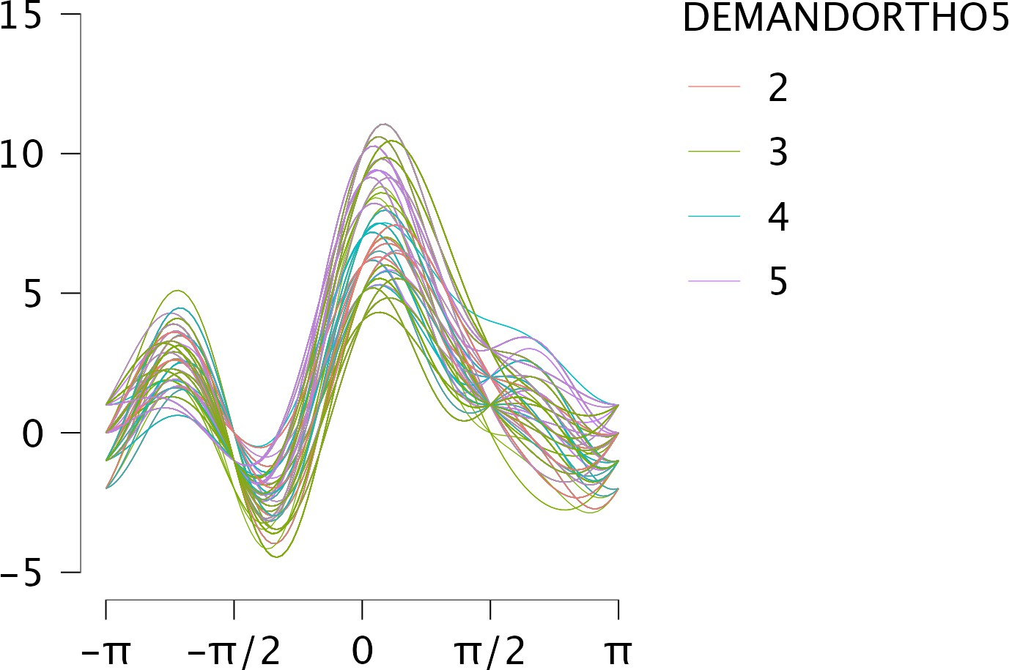

Decision Tree Classification

Complexity penalty Splits

n(Train)

n(Test)

Test Accuracy

# 0.01

12 539

134 0.67

*Note.* The trained model is not saved until 'Save trained model' is checked.

**Data Split**



Confusion Matrix

|  |  |  |  |  |
| --- | --- | --- | --- | --- |
|  | |  | Predicted |  |
| 0 |  | 1 |
| Observed | 0 | 78 |  | 8 |
|  | 1 | 36 |  | 12 |

Class Proportions

Data Set

Training Set

Test Set

0

0.64

0.65

0.64

1 0.36 0.35 0.36

Obs. in Split

Split Point

Improvement

AREA

539

# 5.00

12.11

DHC-IOTN 163 8.00 7.97

AC-IOTN

# 81 11.00

3.47

*Note.* For each level of the tree, only the split with the highest improvement in deviance is shown.

**ROC Curves Plot**

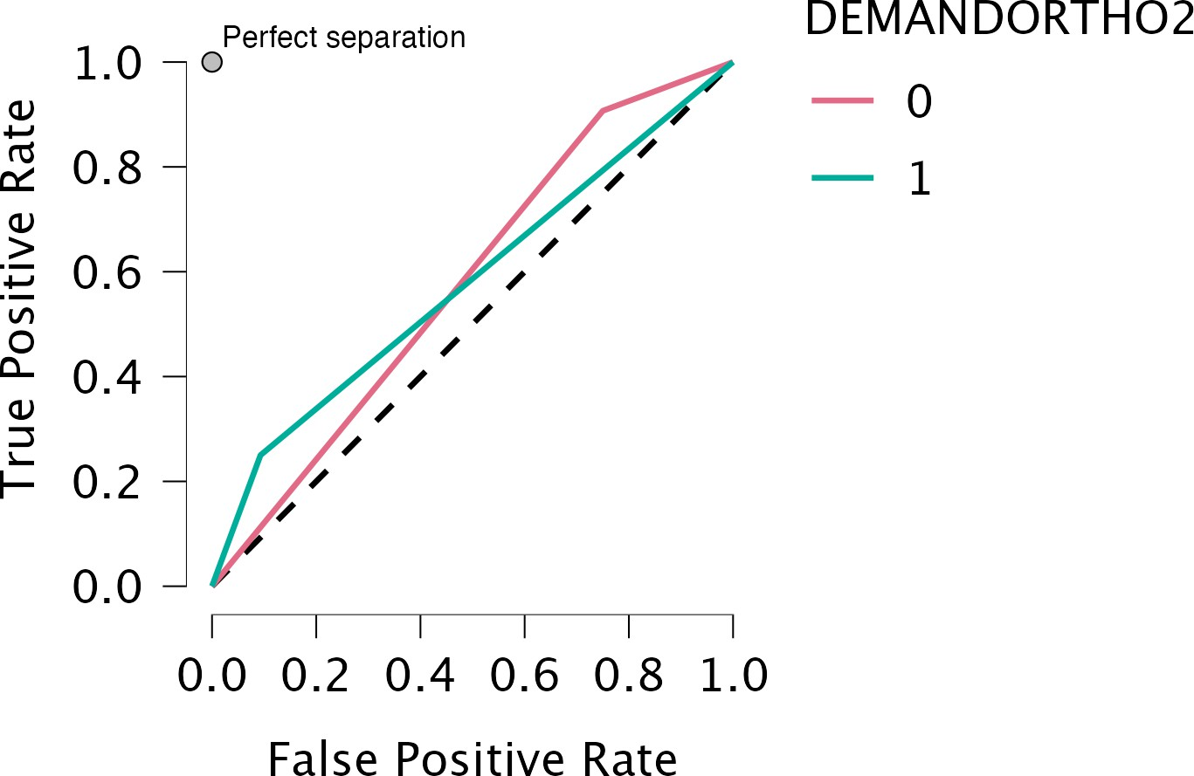

**Andrews Curves Plot**

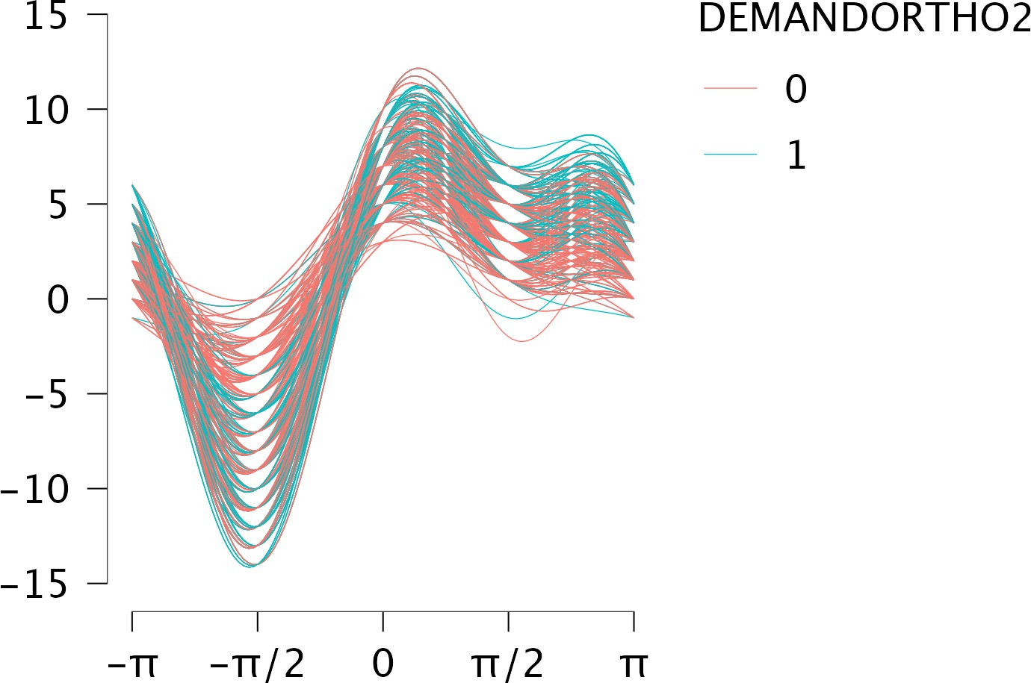

Decision Tree Classification

Complexity penalty Splits

n(Train)

n(Test)

Test Accuracy

# 0.01

13 539

134 0.66

*Note.* The trained model is not saved until 'Save trained model' is checked.

**Data Split**



Confusion Matrix

Predicted

0

1

Observed

0

78

8

1 37 11

Class Proportions

Data Set

Training Set

Test Set

0

0.64

0.65

0.64

1 0.36 0.35 0.36

Obs. in Split Split Point Improvement

|  |  |  |  |
| --- | --- | --- | --- |
| AREA | 539 | 8.00 | 12.11 |
| DHC-IOTN  need3 | 163 | 11.00 | 7.97 |

*Note.* For each level of the tree, only the split with the highest improvement in deviance is shown.

**ROC Curves Plot**

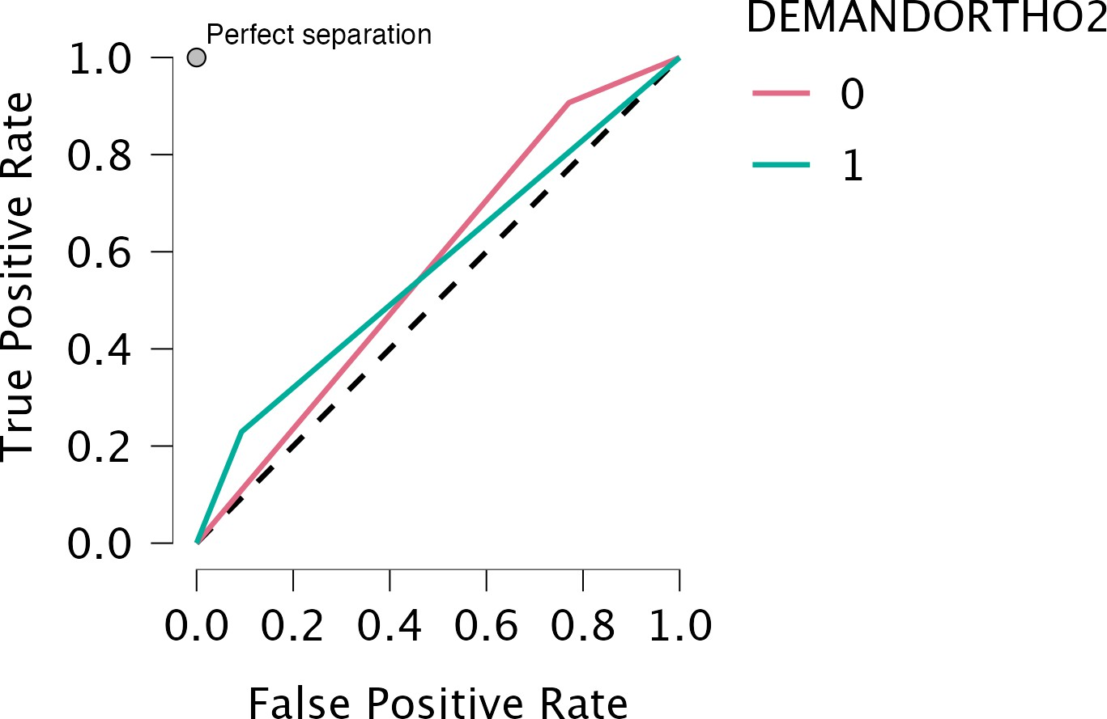

**Andrews Curves Plot**

